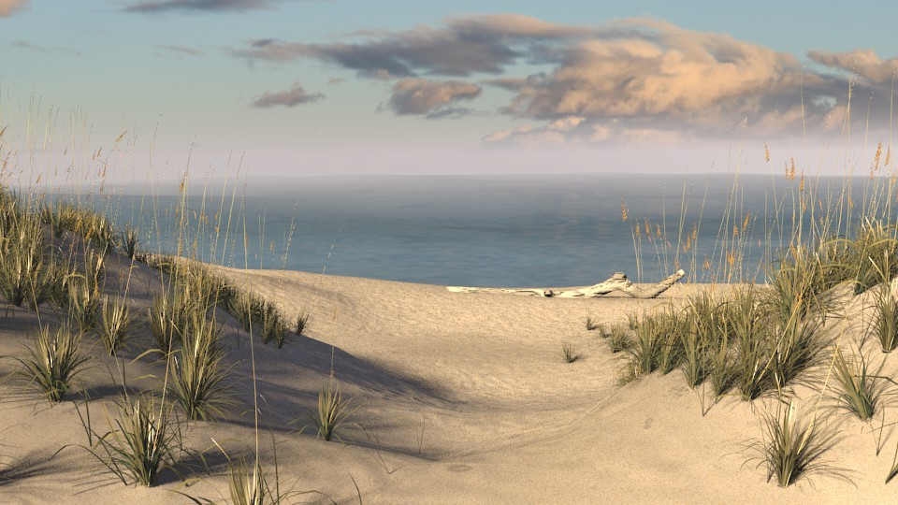

DEICCANA XI

The Road home convention

Is ON!!
January 28th – 30th
Double Tree Hilton
2717 West Fort Macon Rd. Atlantic Beach 28512
For Room Info 252-240-1155
WWW.THEROADHOMENA.ORG
Early Registration $20 From Now thru 11/1/2021
$30 after 11/1/2021
Convention Registration Address:
PO Box 26 Bayboro NC 28515
Or CashApp: $DEICCANA (Subject: Registration)
Registration:252-671-3329 Chair:
Information:252-341-3841
Atmosphere of Recovery
With the Serenity of the Beach

Pet Volunteer Opportunity

The Lamna Animal Shelter is always looking for friendly volunteers that love animals and want to do what they can to help out.
January 25, 2020
11am – 6pm
4567 Main St. Buffalo, NY 68052
  - Sign up at www.lamnahealthcare.com

Pet Volunteer Opportunity

The Lamna Animal Shelter is always looking for friendly volunteers that love animals and want to do what they can to help out.
January 25, 2020
11am – 6pm
4567 Main St. Buffalo, NY 68052
  - Sign up at www.lamnahealthcare.com

